**Name:_______________________________ Date:__________________**

**Partners:___________________________________________________________________**

**JHS Regents Chemistry Department**

**The Bunsen Burner Lab**

**Introduction:** The Bunsen burner is used frequently in the laboratory as a source of heat. This burner is designed so that gaseous fuel may be mixed with the correct amount of air to yield the maximum amount of heat. In order to use this burner properly and safely, it is essential that you understand its construction and the adjustments that can be made.

**Objectives:** To learn the structures and function of a Bunsen burner; To practice proper ignition of a Bunsen burner; To practice using the Bunsen burner safely

|  |
| --- |
| **CAUTION:**   * Wear goggles at all times. * Always Strike the match before turning on the gas valve. * Read all safety guidelines carefully. * Follow the procedures exactly.   Student Signature:_______________________ Date:_______________ |

,

**Background:**

Here is the chemical reaction of the Bunsen burner fuel with oxygen as it burns:  
CH4 + 2O2 —> CO2 + 2H2O

CH4 is called methane and is the major component of natural gas. This equation may remind you of the chemical reaction of the burning of a candle. Notice that carbon dioxide and water are the chemicals that result from the reaction.

Bunsen burners present fire hazards. They produce an open flame and burn at a high temperature, and as a result, there is potential for an accident to occur. For the safety and convenience of everyone working in a laboratory, it is important that the following guidelines be observed. In case of a fire, activate the nearest fire alarm pull station, notify all lab personnel, and evacuate the building. Always follow the precautions below when using the bunsen burner:

1. **Place** the Bunsen burner away from any overhead shelving, equipment or light fixtures by at least 12 inches.
2. **Remove** all papers, notebooks, combustible materials and excess chemicals from the area.
3. **Tie-back** any long hair, dangling jewelry, or loose clothing.
4. **Inspect** hose for cracks, holes, pinch points or any defect and ensure that the hose fits securely on the gas valve and the burner.
5. **Replace** all hoses found to have a defect before using.
6. Strike the match **before** turning on the gas.
7. **Adjust** the flame by turning the collar to regulate air flow and produce an appropriate flame for the experiment (typically a medium blue flame).
8. **Do not** leave open flames unattended and never leave the laboratory while the burner is on.
9. **Shut off** gas when its use is complete.
10. **Allow** the burner to cool before handling. Ensure that the main gas valve is off before leaving the laboratory.

**Pre-Lab Questions:**

**1. What are two gases react to produce the heat of a Bunsen burner?**

**________________ & ________________**

**2. What is CH4? ______________________________________________________**

**3. Why is it important to wear safety goggles when using a Bunsen burner?**

**____________________________________________________________________**

**4. Why is it important to tie back loose hair and clothing when using a Bunsen burner?**

**____________________________________________________________________**

**5. In addition to the items mentioned in questions 3 and 4, what other safety precautions should be followed before lighting a Bunsen burner? (List two.)**

**____________________________________________________________________**

**____________________________________________________________________**

**Materials**: Bunsen burner, matches, tubing, goggles

**Lab Safety:** Goggles must be worn at all times! Please pull all hair back and remove loose clothing such as sweatshirts.

**Lighting and Maintaining a Bunsen Burner Flame**

**Procedure:**

1. Examine your burner when it is not connected to the gas outlet.
   * The barrel is the area where the air and gas mix. Color the barrel green.
   * The collar can be turned to adjust the intake of air. If you turn the collar so that the holes are larger, more air will be drawn into the barrel. Color the collar blue.
   * 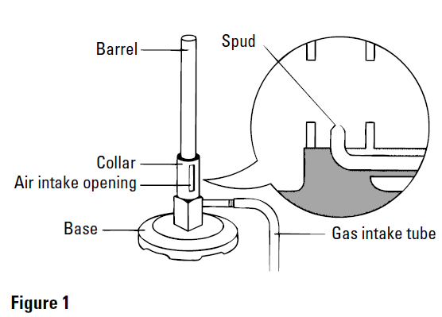The air intake openings are the holes in the collar through which air is drawn in. Color the air intake opening blue.
   * The base supports the burner so that it does not tip over. Color the base orange.
   * The gas intake tube brings the supply of gas from the outlet to the burner. Color the gas intake tube black.
   * The spud is the small opening through which the gas flows. The small opening causes the gas to enter with great speed.
2. Inspect and then connect the fuel tube to the bench fuel valve on the lab table. Connect the other end of the fuel tube to the burner.
3. Adjust the collar so that the air intake openings are half open.
4. Light a match or lighter and hold it approximately 2 cm above the edge of the burner’s barrel *before turning on the gas.*
5. Turn on the lab bench fuel valve; a valve is open if the handle is in line with the outlet—it is closed if it is at right angles to the outlet. (The burner can be turned off by closing the fuel valve.)
   * **CAUTION**: To avoid burns on your hands, always use extreme care when handling lighted matches. Do not lean over the burner when lighting it.
6. 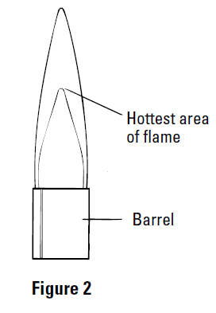You should see a bright yellow flame—the light and color are provided by tiny particles of unburned carbon from the fuel which have been heated to incandescence.
7. The most efficient and hottest flame is blue in color and has distinct regions (see Figure 2, at right) . Adjust the collar so that the flame is blue and a pale blue inner cone is visible. You will hear a rushing sound if you have it right.
8. Do not allow too much air to flow into the barrel since this will just blow out the flame; if this happens, turn off the gas and begin again by closing everything down to the way it was when you started.
9. Put the burner out by shutting off the fuel at the lab bench fuel valve; this the standard procedure for putting out the flame.
10. Make sure that everyone in your group has an opportunity to successfully light the burner; all students should be experienced with this procedure.
11. When all students have practiced lighting the burner, be sure to put it out by turning off the gas.

When you have completed your work in this section please check in with your teacher. This is a required part of the lab and your teacher’s initials are required before you can move on to the next objective. Initials will be given for successfully demonstrating that you can light and correctly adjust the Bunsen burner.

#### Initials ______

#### Questions For Analysis:

1. Describe the flame of a properly burning Bunsen burner.

__________________________________________________________________________________________________________________________________________

1. What does it mean if you have a flame that is tall and bright yellow? How do you correct the problem?

__________________________________________________________________________________________________________________________________________

_____________________________________________________________________

3. Label the parts of the Bunsen burner using the word bank provided.

air hole flame (outer cone) barrel rubber tubing

base flame (inner cone)

A_____________________________

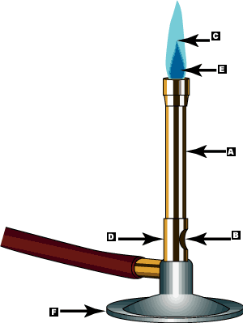

**A**

**B**



**D**

**C**

**E**

**F**

B_____________________________

C_____________________________

D_____________________________

E_____________________________

F_____________________________

Draw an arrow pointing to the hottest part of the flame.